DEAR SHARP PARENTS & FAMILIES, November 19, 2020
Thank you for being very patient with our school personnel during Pandemic times. We have both arrival and dismissal procedures in place in order to facilitate a smooth and safe process. Below are some procedures to follow for those returning face to face for the period of Nov. 30, 2020 –Dec. 18, 2020.
ARRIVAL TIME
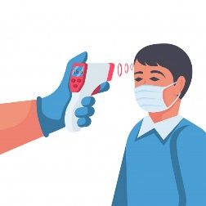
The student designated drop off area in the mornings is by the gym drive-by only. Cars will arrive by the gym door and busses will arrive by the canopy next to the gym.
School personnel will be readily available to check your child’s temperature and assure all students safety.
A KIOSK & a hand held THERMOMETER are both used to assure all students do not have a fever before the parents depart.
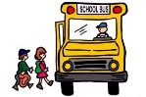
We have our school personnel receiving students in this area starting at 7:30a.m. – 8:00 a.m. If you arrive after 8am, please ring the front gate bell. Wait for the front clerk to assist you at the gate and then the parent may leave. Please do not drop off any student and leave unattended outside the gate.
DISMISSAL TIME
We have the same locations for our dismissal process. All students will be dismissed by the gym drive-by only. Please make sure you bring your bus tag or car tag number every day to pick up your child/ children between 3:15 pm – 3:45 pm.
If your child is taking the BUS, they will wear a bus tag number and are dismissed from the gym also.
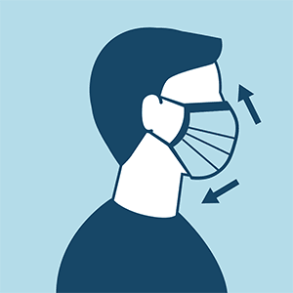
IT’S VERY IMPORTANT THAT ALL PARENTS ASSURE THEIR STUDENTS BRING THEIR DISMISSAL TAG DAILY TO ASSURE A SAFE AND SMOOTH DISMISSAL.
Again, we thank you for being very cooperative and patient as we dismiss our students in a safe manner.
REMINDERS
- Please wear your facial mask and or face shield daily.
- Please bring your device and student workbooks to school and back home daily.
- Please make sure you bring your bus tag or car tag number every day to pick up your child/ children.
- If you or any designated pick-up person doesn’t have their tag number, please be prepared to come to the front gate to show your I. D.
- Please make sure you do not use your cell phone when driving-up to pick-up your child. This is law and it’s also ensuring safety for all.
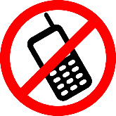
- Please be patient with our staff, as they are all trying to dismiss all our students accordingly and safely.
- Please make sure you have submitted your STUDENT RELEASE CARD to your teacher or Front Office Clerk.
- Any student experiencing symptoms will be escorted to the nurse and parents will be notified immediately.

THANK YOU FOR YOUR CONTINUED SUPPORT!!!!

